Behavioral Health Coalition Petition Email

Petition Link
http://www.ourhealthcalifornia.org/petitions/tell-california-candidates-to-make-mental-illness-and-substance-use-issues-a-priority/

Email

Subject line // preview text options:
[petition] Mental health care in California // Our elected leaders should make it a priority.
We can’t fail California families // Our state must address the behavioral health crisis.

We have a health care crisis:

- In California, 6 million people live with a mental illness, and 2 out of 3 won’t get the treatment they need.
- By 2020, mental illness and substance use disorders will surpass all physical diseases worldwide as major causes of disability.
- One in five children right now has a diagnosable mental illness.
These numbers represent real people — siblings, spouses, and best friends — who are struggling with a range of behavioral health conditions.

Before November’s election, we’re joining Behavioral Health Action and Our Health California in sending California’s candidates and elected leaders a message: Address the mental health care and substance use disorder crisis.

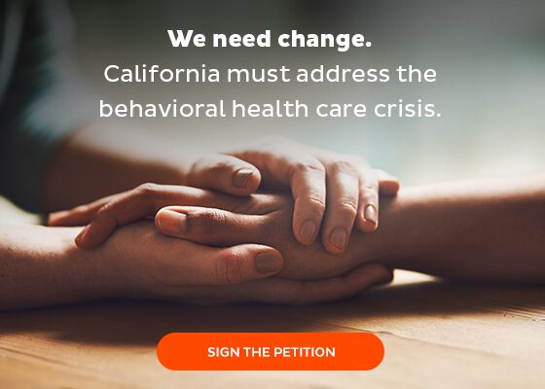
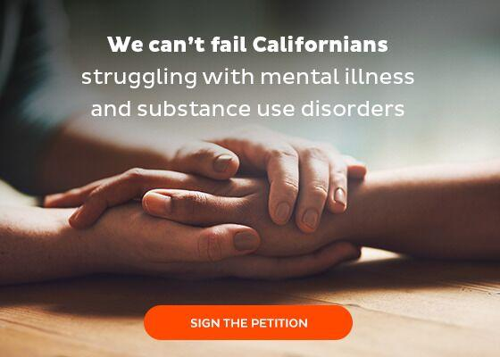

There’s no quick fix for behavioral health issues like mental illness and substance use disorders — so for those that need help, there’s no time to waste.
That’s why we’re asking California’s current and future elected leaders to make solutions a priority and increase access to care for mental illness and substance use disorders.

Sign the OHC petition and tell California’s candidates and elected officials to make mental illness and substance use care a top priority. OHC will deliver these petitions before November’s election.

When California has led on important issues in the past, the rest of the country has followed. Once again, our state can set our country on the right path — a path that helps all Americans access the mental health care they need and deserve.
Together we can help everyone get the care they need.

Thank you,

[SIGNER]

P.S. We need to help Our Health California send 20,000 petitions before November’s election to show California’s candidates — and those already in office — that we want answers. Sign your name today and OHC will deliver your petition before the election.

